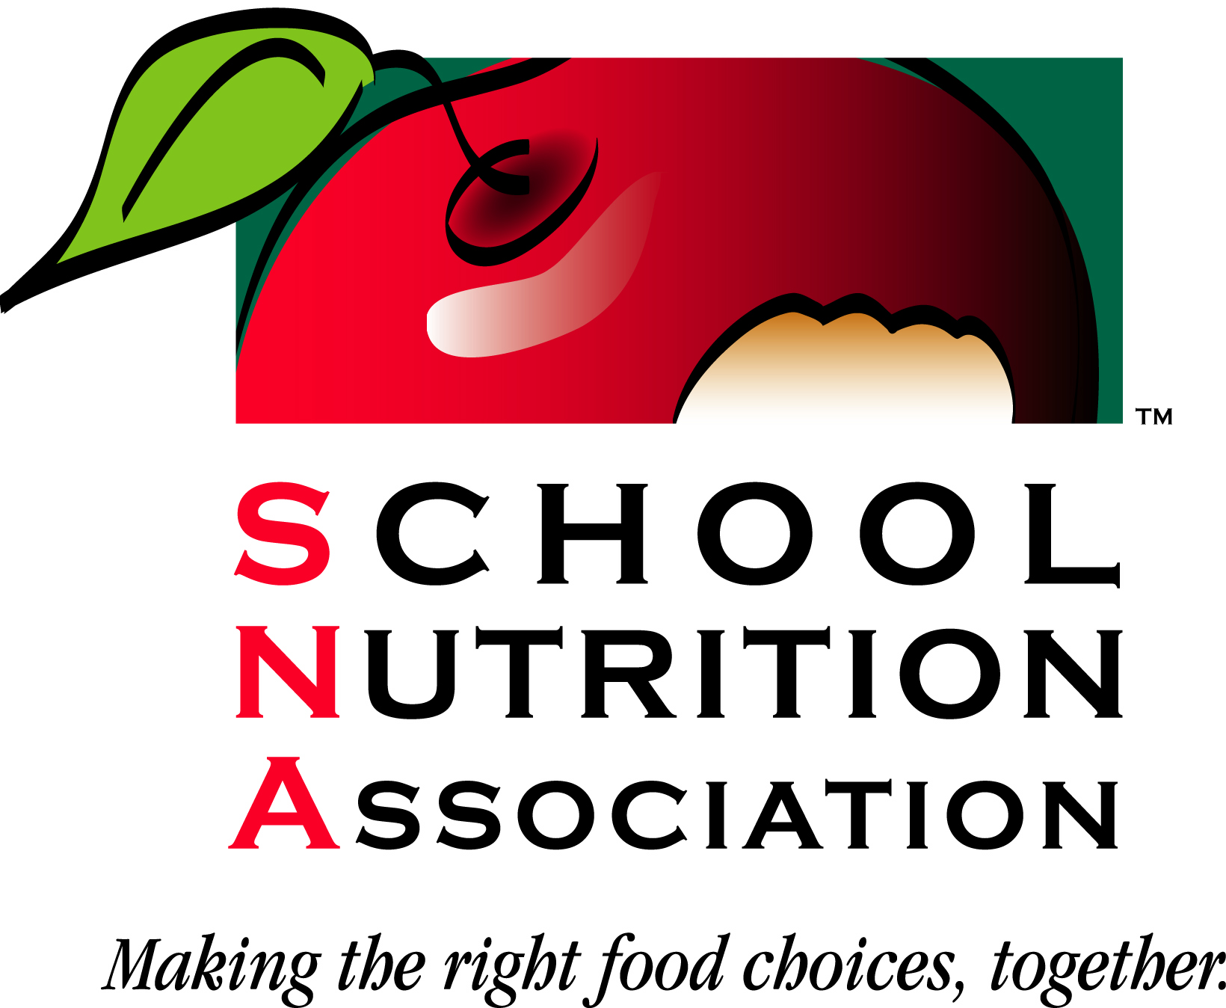
School Nutrition Association
KEY AREA APPROVAL FORM
Must be submitted 6 weeks PRIOR to program date (SNA) or
4 weeks for in-state (WSNA) programs.
See page 2 for more information & instructions for submission.

For SNA or WSNA Use Only
Date Received: _________
Date Processed: ________
Number of Hrs approved:
__________
Number of Hrs requested: ___________
Approved by:

PROVIDER DETAILS
Educational Provider (ie. Chapter/District): _____________
Address: ___________________
City, State & ZIP: ___________________
Contact Person: _______________________________
Email: _________________________
Phone: ______________________________________ FAX: ________________________________________

Signature of Contact Person: ___________

PROGRAM DETAILS
Program Title: _____________________________________________________________________________
Program Date & Time(s): ______________________________ Location (City/State) _______________________
Is this program being held in more than one state or nationally? □ Yes □ No
Key Area (Check One): ___#1 Operations ___#2 Nutrition ___#3 Administration ___#4 Communications/Marketing
Number of Hours Requested: (must be at least 2 hours of active instructional time - does not include breaks, registration, warm-ups.)

Program Type: □ Workshop □ Conference □ Seminar □ Chapter Meeting
□ Satellite □ *Home Study □ Online □ Employee Training

*Home-Study Programs - The following is required:

- Participant must complete an evaluation or test that documents that the program was completed.
The evaluation or test must then be submitted to the educational provider.

REQUIRED ATTACHMENTS

□ *Program Description □ **Learning Objectives
□ **Program Evaluation Form □ **Copy of Presentation (Handouts, PowerPoint)
□ *Printed Program Agenda/Outline to include: □ **Speaker Bio (Qualifications/Degree/Current Position)
Instructor, sessions & times, registration, breaks. Meals
Be sure to list time frames; ie., 2 – 4 pm.

*Required for all applicants.
** Not required for chapter meetings. Required for third party applicants (distributors, brokers, districts, etc.)

GUIDELINES

A. Who should approve your program?

WSNA approves Key Area programs being held within our state. SNA headquarters will approve only those Key Area programs offered in more than one state or other organization’s national conference. The Key Area Approval Form should be submitted prior to offering the program.

B. What are Key Area Programs?

Key Area Programs are directly related to the Key’s to Excellence and must be at least 2 hours of instructional time. The programs must fall under the following areas:

- Key Area 1 – Operations
- Key Area 2 – Nutrition
- Key Area 3 – Administration
- Key Area 4 – Communications/Marketing

- Are educational providers required to provide documentation of completion?

Yes. Each participant should receive documentation of completion for the Key Area Program completed. This may be in the form of a certificate, transcript and/or confirmation notice of attendance.

IN-STATE PROGRAM:

- Send two (2) copies of this form and one (1) copy of the “Sign In” Roster, and one (1) copy of the Credit Activity Form plus a self-addressed stamped envelope to the following certification representative for approval:
Cindy Terry, Certification & Membership Chair
225 South 152nd Street
Burien, WA 98148
If you prefer to correspond via email, please contact Cindy at Cindy.Terry@highlineschools.org .
- Send a copy of this form when approved to your Regional Lead.
- Wait for approval to hold your program.
- File this approved form and keep for SNA auditing purposes along with completed “Sign-In” roster.

Questions: Contact Cindy Terry, WSNA Certification & Membership Chair, at 206 631-6749 or 206-334-0877 or email at Cindy.Terry@highlineshools.org.

NATIONAL PROGRAM or BEING HELD IN MORE THAN ONE STATE

If this program is being held in more than one state, please mail or fax the completed form and attachments to SNA Headquarters:

Mail to: School Nutrition Association
Attn: Certification & Credentialing Manager
700 S. Washington St., Ste. 300
Alexandria, VA 22314

Or Fax to: SNA Certification & Credentialing Manager (703) 739-3915

