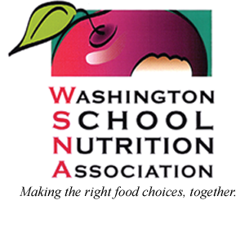

Our Mission
Educating and empowering WSNA members to provide healthy meals
to foster an environment where children achieve overall wellness and lifelong success

Our Vision
Healthy well-nourished students prepared for success

Our Core Values
Child Nutrition advocacy and leadership
Lifelong learning
Diversity and equality
Health and wellness
Camaraderie, community, and fun
Collaboration to create strong viable partnerships

Who are we?
We are a statewide nonprofit association of school and childcare food service professionals, industry representatives, and others who are committed to furthering the goals of the organization.

With the goal of providing nutritious meals for children, we place a strong emphasis on the continuing education of all child nutrition professionals by sponsoring workshops, conferences and trainings.

Our 2,400 members touch the lives of children in Washington State every day.

