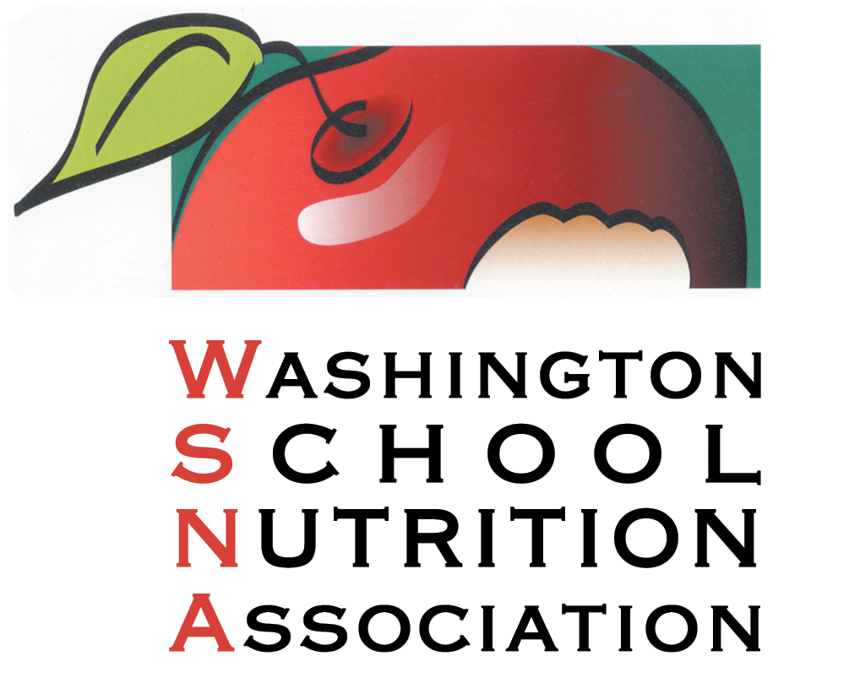
WSNA Spring Workshop
Virtual Platform
Saturday March 27th
Workshop Earns 3.5 CEUs toward Professional Standards

7:30-8:15 Welcome, Flag Salute, Introductions Marcia Wagner
SNA/WSNA discussion

8:15-8:30 Break

8:30 – 9:30 Safety in the Workplace NCESD

9:30-9:40 Break

9:40- 10:40 Personal Wellness: Eating for Health Washington Dairy Council

10:40-10:50 Break

10:50-11:50 Leading Ourselves & Others in Uncertain Times Jan MacDonald

11:50-12:00 Wrap Up

Thank you to our WSNA Platinum Partners:

Acosta, Affinity Group/Elite, Foster Farms, General Mills, Health-e Pro
JTM Food Group, Schwan's, US Foods, & Washington Potato Commission

